Launch Day Post: DOP January 24,2023

Finally, It's here...𝗧𝗛𝗘 𝗦𝗪𝗜𝗧𝗖𝗛 𝗬𝗢𝗨 𝗛𝗔𝗩𝗘 𝗕𝗘𝗘𝗡 𝗪𝗔𝗜𝗧𝗜𝗡𝗚 𝗙𝗢𝗥! 𝗜𝗻𝘁𝗿𝗼𝗱𝘂𝗰𝗶𝗻𝗴 𝗡-𝗧𝗿𝗼𝗻 𝗦𝗲𝗿𝗶𝗲𝘀 𝗡𝗧𝟱𝟬𝟬𝟬 𝗚𝗶𝗴𝗮𝗯𝗶𝘁 𝗠𝗮𝗻𝗮𝗴𝗲𝗱 𝗦𝘄𝗶𝘁𝗰𝗵𝗲𝘀! Designed to keep your network connected and protected, N-Tron series NT5000 gigabit managed switches provide ease of use, reliability, and security features to maximize operating performance and system uptime. Learn more: https://www.redlion.net/products/industrial-networking/ethernet-solutions/managed-ethernet-switches/nt5000-gigabit-managed-layer-2-industrial-ethernet-switches
#Networking #IndustrialNetworking #ManagedEthernetSwitches #EthernetSolutions #Industry40 #RedLionControls #TheIndustrialDataCompany #IIoT #IntuitiveNetworking
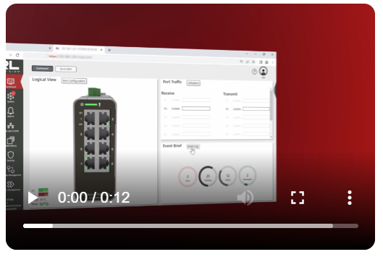

Post launch 1: DOP January 25, 2023
The NT5000 is loaded with security features to help administrators protect the network from unauthorized access. These gigabit switches are designed to provide years of reliable operation, even in harsh industrial applications.
Click here to know more: https://okt.to/8W4STQ #Networking #IndustrialNetworking #ManagedEthernetSwitches #EthernetSolutions #Industry40 #RedLionControls #TheIndustrialDataCompany #IIoT #IntuitiveNetworking
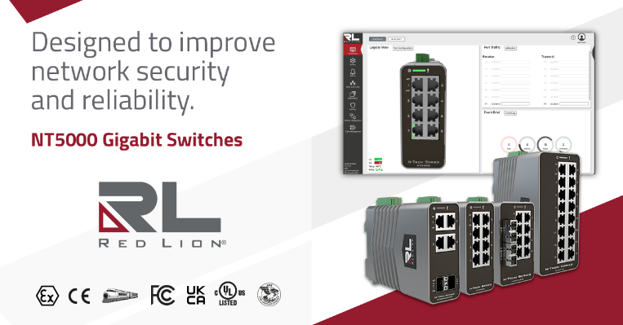

Post launch 2: DOP January 27, 2023
Not all switches have layered network security features to help prevent unauthorized access. The N-Tron Series NT5000 switches feature password encryption, multilevel user access and MAC security, IEEE 802.1X with RADIUS remote authentication, and more. Learn more: https://okt.to/8W4STQ
#Networking #IndustrialNetworking #ManagedEthernetSwitches #EthernetSolutions #Industry40 #RedLionControls #TheIndustrialDataCompany #IIoT #IntuitiveNetworking
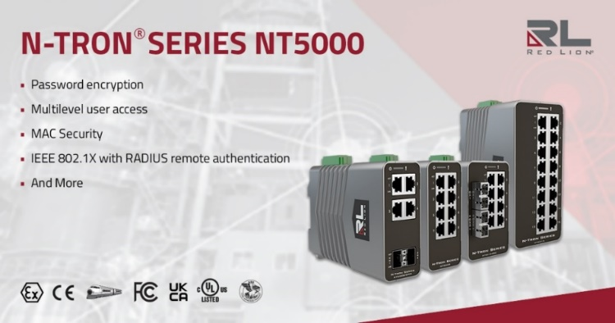

Post launch 3: DOP January 30, 2023
The NT5000 is loaded with security features to help administrators protect the network from unauthorized access. Help protect your network from unauthorized access.
Learn more: https://okt.to/8W4STQ #Networking #IndustrialNetworking #ManagedEthernetSwitches #EthernetSolutions #Industry40 #RedLionControls #TheIndustrialDataCompany #IIoT #IntuitiveNetworking
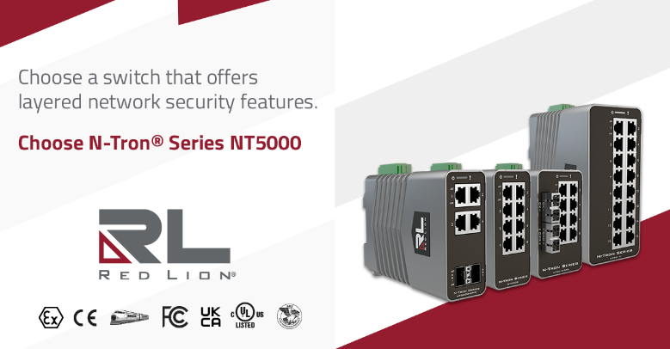

Post launch 4: DOP February 06, 2023
As industries around the world digitally transform and optimize their operations, reliable and secure network access is absolutely critical.
NT5000 switches and their gigabit speed are designed to improve network security and reliability for industrial organizations of all sizes and environments.
Innovative features make installation and setup easy via a configuration wizard, while an industry-ready, rugged design ensures smooth operation in harsh environments.
The NT5000 maximizes operating performance and system uptime through seamless integration, advanced management and diagnostic capabilities, network redundancy and layered security, and helps organizations meet information technology and operational technology needs for dependable communication.
𝗦𝗘𝗧𝗧𝗜𝗡𝗚 𝗔 𝗡𝗘𝗪 𝗦𝗧𝗔𝗡𝗗𝗔𝗥𝗗 𝗙𝗢𝗥 𝗖𝗢𝗡𝗡𝗘𝗖𝗧𝗜𝗩𝗜𝗧𝗬, 𝗥𝗘𝗟𝗜𝗔𝗕𝗜𝗟𝗜𝗧𝗬 𝗔𝗡𝗗 𝗦𝗘𝗖𝗨𝗥𝗜𝗧𝗬 𝗙𝗘𝗔𝗧𝗨𝗥𝗘𝗦
Learn more: https://www.redlion.net/products/industrial-networking/ethernet-solutions/managed-ethernet-switches/nt5000-gigabit-managed-layer-2-industrial-ethernet-switches
#Networking #IndustrialNetworking #ManagedEthernetSwitches #EthernetSolutions #Industry40 #RedLionControls #TheIndustrialDataCompany #IIoT #IntuitiveNetworking
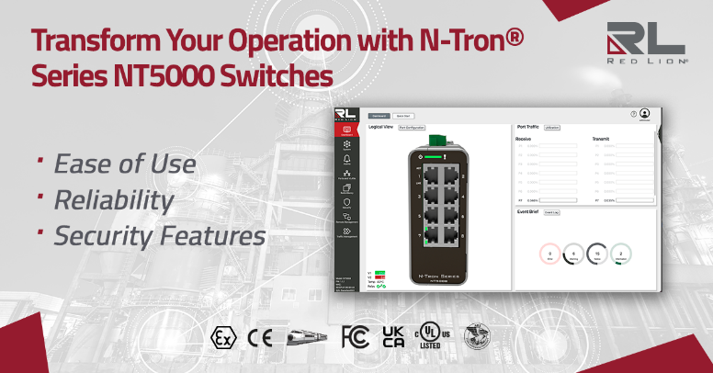

Post launch 5: DOP February 16, 2023
Designed to keep your network connected and protected, Red Lion’s N-Tron series NT5000 switches provide ease of use, reliability, and security features to maximize operating performance and system uptime.
𝗖𝗢𝗡𝗡𝗘𝗖𝗧 𝗧𝗢 𝗬𝗢𝗨𝗥 𝗗𝗔𝗧𝗔 𝗟𝗜𝗞𝗘 𝗡𝗘𝗩𝗘𝗥 𝗕𝗘𝗙𝗢𝗥𝗘
Learn more: https://www.redlion.net/products/industrial-networking/ethernet-solutions/managed-ethernet-switches/nt5000-gigabit-managed-layer-2-industrial-ethernet-switches
#Networking #IndustrialNetworking #ManagedEthernetSwitches #EthernetSolutions #Industry40 #RedLionControls #TheIndustrialDataCompany #IIoT #IntuitiveNetworking
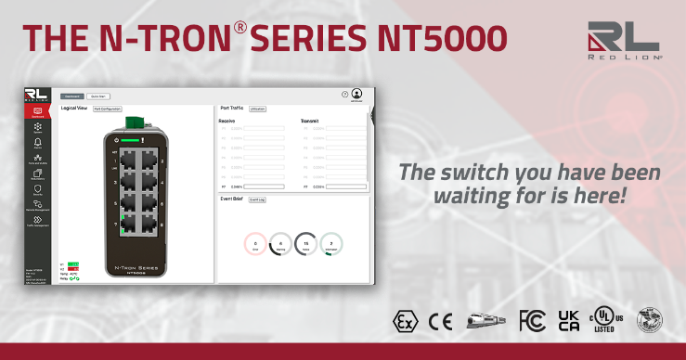

Post launch 6: DOP February 20, 2023
The NT5000 gigabit switches are designed to provide years of reliable operation in harsh industrial applications.
𝗔 𝗗𝗨𝗥𝗔𝗕𝗟𝗘 𝗗𝗘𝗦𝗜𝗚𝗡 𝗙𝗢𝗥 𝗘𝗩𝗘𝗥𝗬 𝗔𝗣𝗣𝗟𝗜𝗖𝗔𝗧𝗜𝗢𝗡.
Learn more: https://www.redlion.net/products/industrial-networking/ethernet-solutions/managed-ethernet-switches/nt5000-gigabit-managed-layer-2-industrial-ethernet-switches
#Networking #IndustrialNetworking #ManagedEthernetSwitches #EthernetSolutions #Industry40 #RedLionControls #TheIndustrialDataCompany #IIoT #IntuitiveNetworking
