**Post #1:**

Crimson®’s web-enabled remote monitoring allows organizations to monitor and control their operations from any location in real-time on their phone, tablet, or pc, reducing costly site visits. A rugged Graphite HMI complete with built-in web server, sunlight-readable display, and NEMA 4X/IP66 rated enclosure is the optimum solution for your most rugged remote outdoor applications.

Read more 👇

<https://bit.ly/3GHOula>

#HMI #Graphite #IndustrialAutomation #RedLionControls

**Post #2**

Monitor your assets and receive SMS message alerts in real-time with our Crimson® powered HMIs. The CR3000 is available in 4-inch to 15-inch models, providing powerful visualization of your critical applications. It triggers real-time alerts, initiating actions that prevent costly downtime.

Visit ➡ [https://bit.ly/3Lc4IWE](https://bit.ly/3Lc4IWE%20) for more details!

#HMI #CR3000 #IndustrialAutomation #RedLionControls

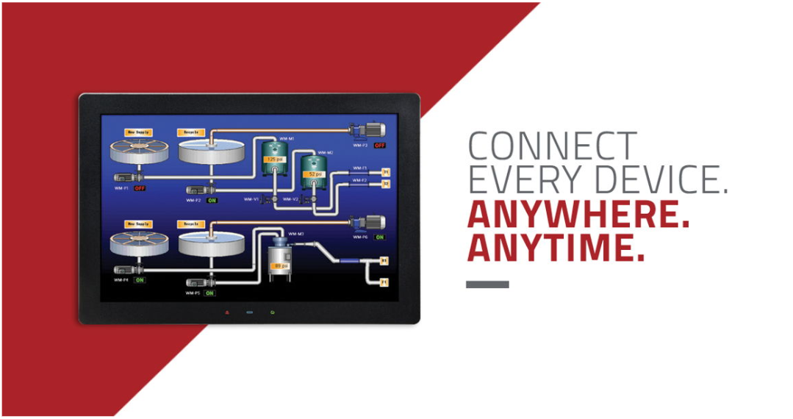

**Post #3**

Red Lion's Crimson® software streamlines your operations, connecting your disparate assets and allowing you to cost-effectively scale your production lines. Our Crimson-enabled CR3000 HMI supports up to 20 simultaneous protocol conversions. With over 300 industrial drivers to choose from, Crimson is the only platform you need to connect, monitor, and control.

Learn more 👉 https://bit.ly/37HX6g8

#HMI #CR3000 #IndustrialAutomation #RedLionControls

