INSTRUCTIONS FOR COMPLETING END-USER, END-USE CERTIFICATION

Give the Quantity, Model or Part Number and describe the product being purchased.

- Purchaser Name should be the same as stated on the Purchase Order and on Letters of Credit.

- INTERMEDIATE CONSIGNEE. Provide the complete name and address of anyone who will receive the goods and forward them on. If you have freight forwarders who handle your shipments, list them here. P.O. Box numbers are not accepted.
If there is no Foreign Intermediary, enter “None.”

- CONSIGNEE. Provide the complete name and address of anyone who will receive the shipment for storage, modification or incorporation into another end-item and for forwarding to the foreign end-user. In some cases the end user may be the purchaser, an in other cases, the articles may go to multiple contractors, system integrators, shipyards or manufacturers before the final end product is delivered to the end user. If so, list their names, addresses and the Role they perform. This information is required on an export license application.

- END USER. Clearly identify the entity that will take final possession of the commodity and be the recipient and user of the systems. For example, “The systems are being procured by the Norwegian Ministry of Defense for use by the Norwegian Royal Air Force.” Provide the address of the End User, including street address (not P.O. Box or an address for a location ‘under construction’) because the export license application requires this information and the State Department and Commerce Department will not accept general or imprecise addresses. Provide the complete names (acronyms are not permitted). Writing “Military” without describing which service branch is unacceptable to the licensing agency.

In situations where the commodity is being installed in a facility that is being built and the final end user cannot be identified, the contractor responsible for the construction must be identified and pertinent information provided.

- COUNTRY OF ULTIMATE DESTINATION. This is the country where the items will ultimately be located. If this is different from the country in item 5, please explain.

- END USE. This short statement should describe the specific system in which the product will be used. State whether the ultimate end use will be a military or commercial application. Include the name of platform (item 8) on which the product will be used. If applicable, provide the name of a Program (item 9) that identifies the end use so that the U.S. Licensing Agency can understand where and how the products are going to be used.

- Platform used on. This should indicate in what environment the product is being used (ex: Industrial is insufficient. Specificity is required (ex: Gas Turbine Power Plant).

- Program Name/Description: Directly relates to 8 above and needs to include a description of how the product will be implemented (ex: Product is used to monitor the pressure in the gas turbine).

REQUIRED CERTIFICATION. You must make the statement certifying that the items will not be used for the purpose of any Chemical, Biological, Nuclear Weapons, or Missile programs (ballistic or cruise) and that the items are not for re-export to anyone not stated on the end-use certification. THESE CERTIFICATIONS MUST BE PROVIDED TO THE U.S. GOVERNMENT IN ENGLISH BY THE END USER, ON THE END USER’S LETTERHEAD. In some cases, we may decide that a license is not necessary, but this certification is still required for us to make that determination.

Insufficient or incomplete information on this certification will delay your procurement.

Thank you in advance for helping us process your order.
Red Lion Controls, Inc.

WHY END-USE/END-USER CERTIFICATION IS REQUIRED BY RED LION

Controlled Products
Red Lion Controls (RLC) products are subject to U.S. export control laws and regulations. At a minimum, RLC products cannot be exported or re-exported to certain prohibited destinations, to prohibited users, or for prohibited uses as discussed below. In addition, certain RLC products may be controlled on the Commerce Control List (CCL) of the U.S. Export Administrations Regulations (EAR), or the U.S. Munitions List (USML) of the International Traffic in Arms Regulations (ITAR) and may require a license from the U.S. Government for export or re-export even to friendly countries. In particular, articles specially designed or modified for defense applications will require a license for export to any destination.

Controlled Technologies
Technical information that may be provided to you by RLC, such as drawings, diagrams, user manuals, etc., are also subject to U.S. export control laws and regulations as described above. Exports or re-exports of such information must be made only in compliance with U.S. law, which may require an export license for certain information. An “export” includes giving a non-U.S. person, such as a foreign-national employee or visitor, access to such information, even in the United States.

Prohibited Destinations
RLC products and technical information may not be exported to countries which are subject to trade embargoes. Whether or not explicitly required by local regulations, RLC may, at its sole discretion, require additional due diligence with respect to any country or region, not just those established in the table below, that RLC considers to be a “red flag”. In addition, the ITAR and EAR contain additional prohibited destinations. Updated prohibited destination lists are found at:
- http://www.treasury.gov/about/organizational-structure/offices/Pages/Office-of-Foreign-Assets-Control.aspx
- https://www.pmddtc.state.gov/embargoed_countries http://www.pmddtc.state.gov/embargoed_countries/index.html
- https://www.bis.gov/regulations (see Part 746)
[The above-referenced lists are not all inclusive and may be revised from time to time.]
Prohibited Users
RLC and technical information will not be resold, re-exported, or transferred to any prohibited persons or entities included on the Specially Designated Nationals List, Denied Persons List, Unverified List, Entity List, AECA Debarred list, and Nonproliferation Sanctions List. The lists can be accessed at https://www.export.gov/article2?id=Consolidated-Screening-List.

Prohibited Uses
RLC products may not be used without the appropriate U.S. Government authorization for:
- Designing, developing, fabricating nuclear weapons or nuclear explosive devices; or devising, carrying out, or evaluating nuclear tests or nuclear explosions;
- Designing, assisting in the design of, constructing, fabricating, or operating facilities for the chemical processing of irradiated special nuclear material, for the production of heavy water, for the separation of isotopes of any source and special nuclear material, or specially designed for the fabrication of nuclear reactor fuel containing plutonium;
- Designing, assisting in the design of, constructing, fabricating, furnishing or modifying equipment for the fabrication of chemical or biological weapons, chemical precursors, viruses, viroids, bacteria, fungi or protozoa;
- Designing, assisting in the design of, constructing, fabricating or furnishing equipment for components specially designed, modified or adapted for use in such facilities;
- Designing, developing or producing rockets or missiles;
- Training personnel in any of the above activities.

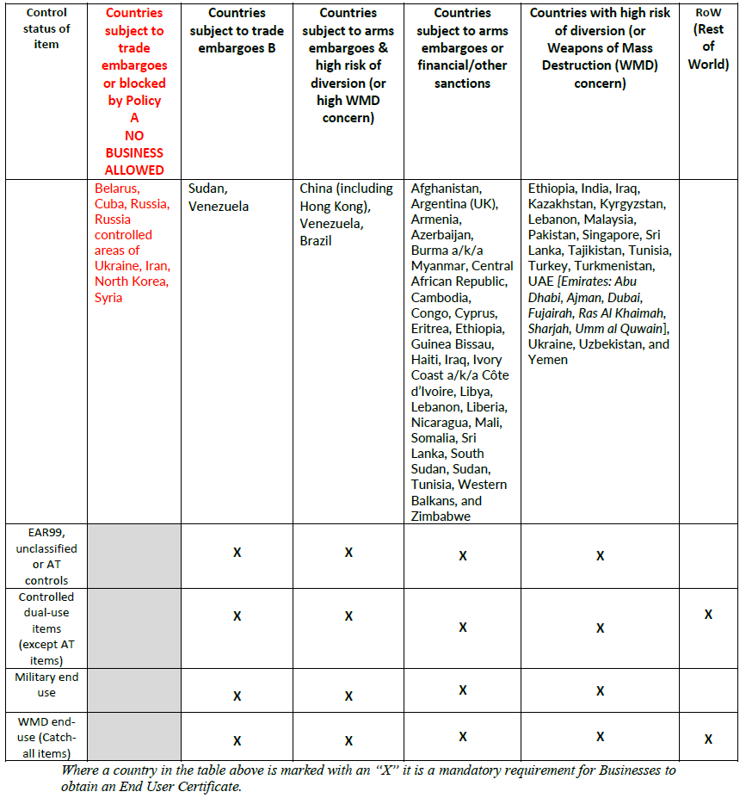

[PRINT ON COMPANY LETTERHEAD]
Click or tap to enter a date.

(Customer Name & Address)

FAO Export Controls Compliance Officer, Red Lion Controls, Inc. (RLC)

END-USER ASSURANCE CERTIFICATION FORM

We (company), certify that we are the purchaser of the items described below and will not export, re-export, resell, transfer or otherwise dispose of such items contrary to applicable export controls.

- Product(s) being Purchased:
Quantity | Model / PN | Description

- Purchaser/Reseller
Name on Order:
Street Address:
Street Address:
Street Address:
City/District/Providence
State/Country

2. Purchaser/Reseller
Name on Order:
Street Address:
Street Address:
Street Address:
City/District/Providence
State/Country

- Intermediate Consignee (if applicable)
Organization Name:
Street Address:
Street Address:
Street Address:
City/District/Providence
State/Country
Role:

- Intermediate Consignee (if applicable)
Organization Name:
Street Address:
Street Address:
Street Address:
City/District/Providence
State/Country
Role:

- Consignee (if applicable)
Organization Name:
Street Address:
Street Address:
Street Address:
City/District/Providence
State/Country
Role:
- Consignee (if applicable)
Organization Name:
Street Address:
Street Address:
Street Address:
City/District/Providence
State/Country
Role:
- Consignee (if applicable)
Organization Name:
Street Address:
Street Address:
Street Address:
City/District/Providence
State/Country
Role:
- Consignee (if applicable)
Organization Name:
Street Address:
Street Address:
Street Address:
City/District/Providence
State/Country
Role:
- Consignee (if applicable)
Organization Name:
Street Address:
Street Address:
Street Address:
City/District/Providence
State/Country
Role:

- Ultimate End User
Organization Name:
Street Address:
Street Address:
Street Address:
City/District/Providence
State/Country
Role:

- Country of Ultimate Destination:

- End Use: Commercial Military

- Platform used on: Ship Airborne Satellite Ground-Based Others
Please, specify:

- Program/Project Name:
Describe the type of system for this Program utilizing the exported component(s):

I (we) will abide by all applicable U.S. export control laws and regulations for any products purchased from RLC and will not transfer such technology to a third party (other than an affiliate) without obtaining any licenses or prior approvals required by the U.S. Government prior to such transfer which would result in an export or re-export of RLC products.
We further certify that the product(s) will not be used for proliferation of nuclear, missile, chemical or biological warfare.

Signature: ______________________________

Printed Name: ___________________________

Title: ___________________________________
Date: ___________________________________

